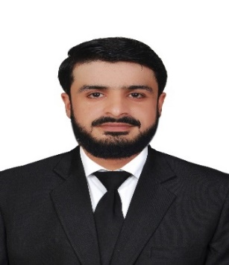
Personal Statement
I am Detail oriented document controller with a strong commitment to maintaining organized and efficient document management systems. My expertise in document control software, rigorous quality checks, and dedication to date security ensures seamless document flow and compliance within the organization.
Education
- M.Phil. in Nuclear Physics,
Gomal University, Session -2020- 2022
Research Thesis Title: “Quality Control Procedure of Different Parameters of X-Ray Machine & optimization of doses to the patient”.
- BS (Hons) in Physics,
Gomal University, Session 2015- 2019
- F. Sc Pre-Engineering
BISE Dera Ismail Khan Session 2013-15
- SSC Science
BISE Dera Ismail Khan Session 2011-13

Technical Education
- B.Ed. in Administration (1.5 Year) 2023
- DIT 1 Year Diploma (KPTTB Peshawar), 2016
Teaching & Work Experience
Lecturer in Physics, In Different Institutions, 1st September 2019 – 2023 August.
Engaging lectures on various physics topics, utilizing multimedia tools to enhance learning experiences.
fostering critical thinking and problem-solving skills among students.
Implemented innovative teaching methods, including group discussions and debates, to promote active learning.
Research Experience
1 Year Research in DINAR
(D.I. Khan Institute of Nuclear Medicine and Radiotherapy).
Conducted simulations and data analysis using computational tools and software.
Computer Skills
Proficient in Microsoft Office Suite (Word, Excel, PowerPoint) for creating engaging presentations and reports also Document Controller Experience in Friends Construction Company.
Experienced in data entry and analysis using Excel and statistical software.
Project management, Technical Knowledge, Strong Communication skills.

Certifications
- WHO Certificate in Public Health, 2020
- LHC 10th School on Physics, 2021
- Computational Material Science Certificate, Gomal University, 2021
- Advanced Computational Material Science Certificate, Gomal University, 2022
Professional Skills
Strong management skills, demonstrated through successful supervision of student projects and academic responsibilities.
Adaptability and resilience, thriving in demanding and high-pressure environments.
Effective communication and presentation skills, facilitating clear and concise knowledge transfer.
Achievements
Awarded "Best Teacher" for outstanding contributions to teaching in Horizon Science High School 2023.
Personal Information:
Full Name : Waris Ali Muhammad Aslam
Nationality : Pakistani
D.O.B. : 28/01/1996
Religion : Muslim
Material Status : Single
Visa Status : Visit Visa (Valid till Nov 02, 2023)
Email : wariscute@gmail.com
Languages:
English : Fluency Written and Verbal Communication
Urdu : Fluency Written and Verbal Communication
Arabic : Basic
References
Available upon request.
Declaration
I confirm that the information provided above is accurate and up to date. I consent to my references being contacted for verification purposes.

